# Job description

## General information

**Job title**: Email Marketing Manager

**Team**: Fundraising and Marketing

**Department:** Digital

**Job location:** Andover/Home/Hybrid

**Reports to:** Head of Digital

**Number of direct reports:** up to 2

**Number of volunteer reports:** 0

**Financial responsibility:** Up to £100,000 Expenditure

**Matrix reporting lines to:** N/A

**Level of disclosure check required and related workforce:**

Basic

## Overall purpose

Every day, around 300 people are diagnosed with macular disease. It’s the biggest cause of sight loss in the UK. Macular disease is cruel and isolating. It steals your sight, your independence, and your ability to do the things you love. There is only one way to Beat Macular Disease for good.

The Macular Society is working to deliver our ultimate ambition – to Beat Macular Disease for the next generation. We are determined to end the fear and isolation of macular disease with world-class research and the best advice and support.

Our Digital team deliver a first-class digital experience to those looking for support and those looking to support us through our website and our busy email programme. The Email marketing manager will support our Head of Digital in delivering successful content utilising their technical skills through our emails. Our audiences expect engaging, accurate and up-to-date content, so a great eye for detail, an understanding of audience motivations and a good sense of design is important, as is confidence in using analytics to advise future activity.

## Organisational chart

## Our values

We will beat macular disease by…

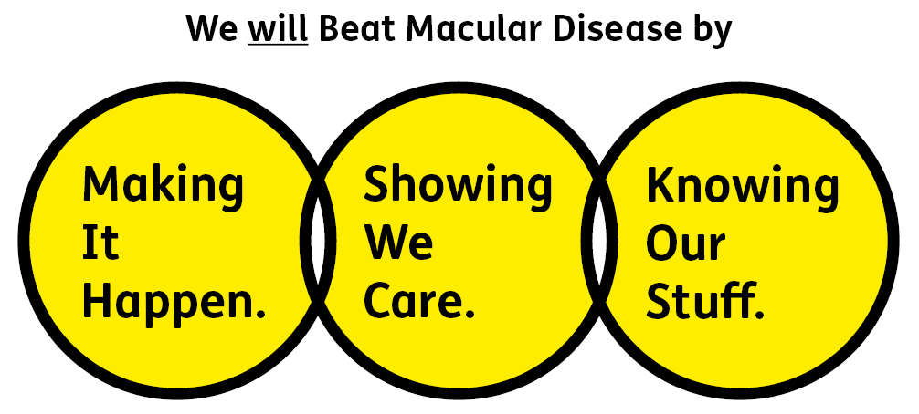

### Showing We Care - we are Supportive and Caring

### Knowing Our Stuff - we have Integrity and we act Honestly

### Making It Happen - we are Ambitious

## Key accountabilities of the role

* Support the organisation through the management, the strategic development and implementation of our digital content strategy – through implementing our busy email marketing programme.
* Create updates and new content for our emails from across the organisation - ensuring it is correct, up to date, relevant, appropriate to the audience and reviewed by stakeholders.
* Working with the Digital Content Manager and other colleagues where appropriate to ensure that online relevant resources including content links, downloads and search results are available for email in a timely fashion.
* Utilise analytics for meaningful reporting and making recommendations and changes as a result.
* Employing sector insights and email best practice to continually refine and improve our email programme.
* Ensure all digital content is accessible and engaging for all audiences with varying levels of sight; creating new templates where necessary.
* Understand key audience profiles and motivations and use this information to engage audiences and inform delivery of content and creative execution.
* Proactively identify and follow up on content opportunities for the Macular Society with both internal and external colleagues.
* Administration of our digital content work via our email platform.
* Monitor, triage and action internal requests as appropriate.
* Assisting with budgetary management, reporting and administration.
* Supporting the digital team as required.

All employees are expected to comply with Macular Society terms and conditions, rules, policies, procedures, codes of conduct, quality standards, authorisation processes, risk management policies etc. and relevant external regulations.

## Competencies

1. Supports and manages their team and colleagues.

2. Works well with others across the Macular Society.

3. Is committed to quality and service.

4. Understands how the Macular Society operates and follows agreed procedures.

5. Delivers their objectives and core activities as required.

6. Takes responsibility for their own performance and development.

## Person specification

**Essential:**

Knowing Our Stuff

* Previous experience in a similar role - ideally within a charity.
* Demonstrable experience of implementing and delivering effective and engaging email programmes.
* Experience and understanding of digital analytics.
* Experience of working with external suppliers.
* Knowledge of and competent in following best practice.
* Experience of working on expenditure budgets.
* Experience of using backend systems such as website CMS and email marketing platforms.
* Excellent verbal and written communication skills.
* Strong IT skills including Word, Excel, PowerPoint, Outlook.

Making It Happen

* Excellent delivery skills and ability to manage diverse and demanding workloads with a multitude of stakeholders.
* Ability to create templates based on audience needs.
* Understanding what works for specific audience groups.
* Ability to work in an agile way, in a test and learn environment.
* Excellent organisational skills and ability to work independently under own initiative and cooperatively as part of the wider organisation.
* Able to prioritise own workload and meet deadlines.

Showing We Care

* Putting the needs of our sight impaired and sighted audiences at the heart of our digital content creation.
* Taking responsibility for the digital content which our audience trusts.
* Good influencing skills with a can-do attitude and hands on approach.
* Excellent team working and collaborative working skills and the ability to develop effective partnerships across teams.
* Commitment to high standards in all areas of work.

**Desirable:**

* Knowledge of and empathy with issues relating to sight loss.
* Working for a charity.
* Understanding of fundraising techniques and different fundraising areas.
* Ability to write and edit HTML.
* Working knowledge of SEO.
* Experience of Dot Digital.
* Understanding of Data Protection legislation.

Eligibility to work in the UK:

* Proof of identity and eligibility to work in the UK.

## Volunteering:

From time to time, you may be asked to support / volunteer your time (TOIL available) at Macular Society events that take place outside of normal working hours.

## Safeguarding:

The Macular Society is committed to safeguarding and promoting the welfare of all children, young people and vulnerable adults with whom we work. We expect all our employees and volunteers to demonstrate this commitment.

The post holder is required to carry out other such duties as may  
reasonably be required, commensurate with the grade of this post. All  
employees are expected to excel in being supporter centric,   
demonstrate advocacy for the Macular Society at all times and be a fundraiser.

This job profile is accurate as at the date shown below. In consultation  
with the post holder it is liable to variation by management to reflect  
or anticipate changes in or to the role.

**Annual leave:** 26 days plus bank holidays (pro rata for part time)

**Based:** Andover/home/hybrid

**Contract Type:** Permanent

**DATE OF EVALUATION:** December 2024