Job description

Job title: Trusts & Philanthropy Fundraising Manager
Team: Trusts & Philanthropy
Department: Fundraising
Job location: Andover or Home Based
Reports to: Head of Trusts & Philanthropy

Overall purpose
Macular disease is the biggest cause of sight loss in the UK, with around 300 people diagnosed every day. The Macular Society is the only charity determined to beat the fear and isolation of macular disease with world class research, and the best advice and support.

To support people affected by macular disease now, the Macular Society provides a range of support, information and services. Our research programme is focused on finding new treatments and a cure to Beat Macular Disease forever.

Organisational chart
This role will work closely with the Head of Trusts & Philanthropy to ensure the growth of income mostly from Trusts, but also from major donors and statutory sources as these areas develop.

The Trusts & Philanthropy Fundraising Manager reports to the Head of Trusts & Philanthropy and line manages one Senior Trusts Officer/Trusts Officer.

Our values
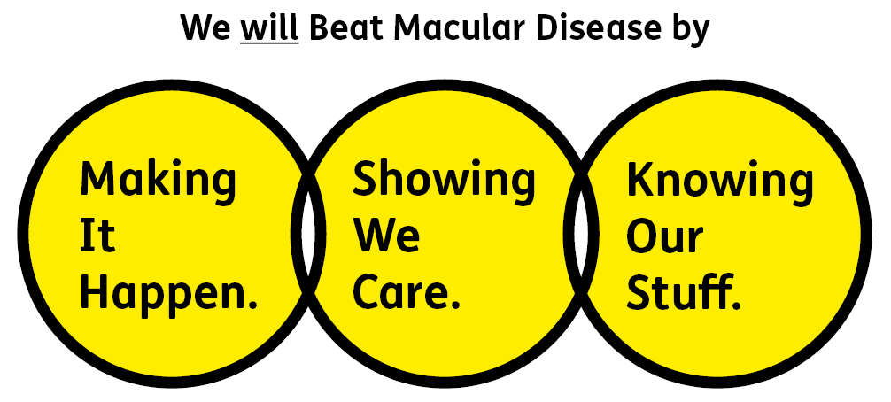
We will beat macular disease by…

Making It Happen - we are Ambitious

Showing We Care - we are Supportive and Caring
- Knowing Our Stuff - we have Integrity and we act Honestly

About the role

- Contribute to the development and implementation of plans to grow income from trusts, major donors and statutory funders by developing excellent written proposals, applications and reports.
- Line manage the Senior Trusts Officer or Trusts Officer.
- Deliver exemplar stewardship to donors which responds to their individual needs and inspires continued support, mostly through written and telephone communications but also includes participation in events, visits and meetings.
- Use fundraising research resources to carry out research to identify and cultivate prospective funders.
- Collaborate with colleagues, especially in the services and research teams, to gather information representing project needs, aims and deliverables; ensuring that what is presented to funders is aligned to the delivery side of the organisation.
- Work with colleagues including budget-holders and finance to develop and monitor projects and budgets for funder reports.
- Ensure the database is kept up to date, to accurately record communications with funders, code income correctly and enable timely reporting.
- Support the rest of the fundraising team when required with specific projects/events.
- Keep up to date with best practice in fundraising and comply with relevant legislation.

All our team members are expected to comply with Macular Society terms and conditions, rules, policies, procedures, codes of conduct, quality standards, authorisation processes, risk management policies and relevant external regulations.

About you
1. You will be committed to equality, diversity and inclusion in all aspects of our work.
2. Have an open and collaborative approach to work, helping us to achieve our Knowing Our Stuff value by working with integrity, making informed decisions to be the best we can be to Beat Macular Disease.
3. Be able to act with empathy, providing a caring, approachable and supportive environment for all – we Show We Care by listening to each other and working together.
4. Be ambitious in your approach to help Make Things Happen, we are progressive yet supportive, and brave in our actions to make the progress that is needed to Beat Macular Disease.
5. Be happy to work in an organisation that puts those we support first, advocate for the Macular Society at all times, and be comfortable that all members of the team are part of our fundraising culture.

Specifically for this role you will have:
Knowing Our Stuff
- A successful track record in trusts fundraising including developing multi-year proposals for 5 - 6 figure gifts, and ideally experience in successfully securing and manging national lottery grant awards.
- An up-to-date knowledge of the trust fundraising landscape and a working knowledge of research sources and methodologies.
- Experience in effectively stewarding funder relationships.

Making It Happen
- Excellent writing skills for delivering inspiring proposals and reports to a deadline.
- Strong organisational and administrative skills and excellent attention to detail.
- Ability to work independently under own initiative and cooperatively as part of a team with colleagues at all levels.
- Ability to multitask and prioritise projects to meet deadlines.
- Strong IT skills including Word, Excel, PowerPoint, Outlook.

Showing We Care
- Experience in developing and maintaining funding relationships that inspire repeat gifts.
- Excellent collaborative working with colleagues to develop effective working relationships to create and manage projects to be funded.
- Knowledge of, or empathy with, issues related to sight loss.
- Commitment to high standards in all areas of work.

You may also have these qualities, but these are not essential:
- Experience of managing people in a collaborative environment.

Eligibility to work in the UK:
Proof of identity and eligibility to work in the UK.

Volunteering:
From time to time you may be asked to support / volunteer your time (TOIL available) at Macular Society events that take place outside of normal working hours.

Safeguarding:
The Macular Society is committed to safeguarding and promoting the welfare of all children, young people and vulnerable adults with whom we work. We expect all of our employees and volunteers to demonstrate this commitment.
You are required to carry out other such duties as may reasonably be required, relevant to the role.
This job description is accurate as at the date shown below. In consultation with you it is liable to variation by the Macular Society to reflect or anticipate changes in or to the role.

Annual leave: 26 days plus bank holidays (pro rata for part time)
Based: Andover, Hybrid or Remote working options considered.
Contract Type: Permanent

Date of evaluation: September 2024

