

Job Description

General Information

Job title: Legacy and In Memory Marketing Manager
Team: Legacy and In Memory

Department: Fundraising and Marketing

Job location: Flexible with some visits to Andover Office

Contract type: 9-month fixed term contract – maternity cover

Reports to: Head of Legacy and In Memory Fundraising

Direct reports: 2

Overall Purpose
Macular disease is the biggest cause of sight loss in the UK, with around 300 people diagnosed every day. The Macular Society is the only charity determined to beat the fear and isolation of macular disease with world class research, and the best advice and support.

To support people affected by macular disease now, the Macular Society provides a range of support, information and services. Our research programme is focused on finding new treatments and a cure to Beat Macular Disease forever.

Role Overview
The Legacy and In Memory Marketing Manager will be responsible for working with the Head of Legacy and In Memory to help develop our Legacy and In Memory marketing strategy, as well as delivering a diverse fundraising programme which aims to grow awareness and inspire action, ultimately increasing future income from legacies and in memory donations.

You will manage our legacy and in memory marketing campaigns, events and materials, being data and insights led and using a range of communication channels. You’ll also ensure that we continue to provide the best supporter experience possible through excellent stewardship of legacy prospects and pledgers, and in memory contacts.

Organisational chart

Organisational chart shows role reporting to the Head of Legacy and In Memory Fundraising and managing two experienced part-time Legacy and In Memory Officers.

Our Values
We will beat macular disease by…

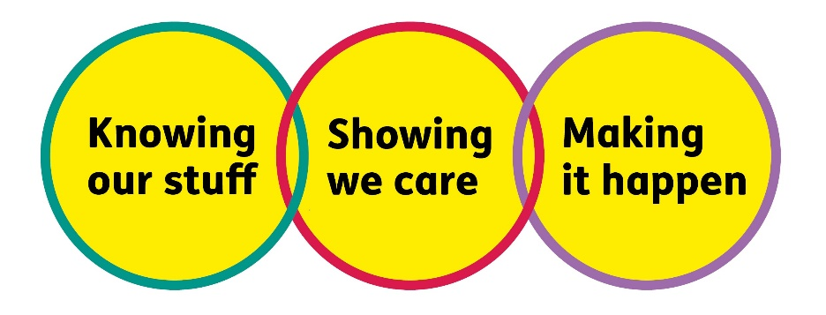

Making It Happen - we are Ambitious

Showing We Care - we are Supportive and Caring

Knowing Our Stuff - we have Integrity and we act Honestly

About the role
- Deliver agreed aspects of the legacy and in memory fundraising programme.
- Project manage legacy direct marketing appeals and campaigns from concept to fulfilment, including targeting, data briefing, creative and delivery.
- Research, create and implement new legacy products to increase legacy pledges and ensure supporter retention.
- Manage, motivate and provide development opportunities for your team, ensuring regular 121’s and appraisals are taking place.
- Research, create and pilot a virtual legacy event offering.
- Manage our stewardship programmes for legacy enquirers, intenders and pledgers, working across teams to identify opportunities to improve experience and maintain support.
- Work with Head of Legacy & In Memory and team to provide content for the legacy newsletter and contribute legacy and in memory articles for other appropriate supporter publications.
- Lead the development of a digital in memory campaign, working with our agency partners, integrating with owned channels.
- Act as a Gifts in Wills ambassador across the organisation, building awareness amongst staff, volunteers and Trustees of the importance of legacy income, motivating them to promote it with confidence.
- Work across teams to identify opportunities for cross working and wider dissemination of legacy messages.
- Maintain an excellent donor experience and a robust donor journey for in memory donors and tribute fundholders, to grow income and encourage future support.
- Assist with the development and reforecasting of budgets.
- Maintain accurate records of all contacts on our database.

All our team members are expected to comply with Macular Society terms and conditions, rules, policies, procedures, codes of conduct, quality standards, authorisation processes, risk management policies and relevant external regulations.

About you
1. You will be committed to equality, diversity and inclusion in all aspects of our work.
2. Have an open and collaborative approach to work, helping us to achieve our Knowing Our Stuff value by working with integrity, making informed decisions to be the best we can be to Beat Macular Disease.
3. Be able to act with empathy, we provide a caring, approachable and supportive environment for all – we Show We Care by listening to each other and working together.
4. Be ambitious in your approach to help Make Things Happen, we are progressive yet supportive, and brave in our actions to make the progress that is needed to Beat Macular Disease.
5. Be happy to work in an organisation that puts those we support first, advocate for the Macular Society at all times, and be comfortable that all members of the team are fundraisers.

Specifically for this role you will have:

Knowing Our Stuff
- Proven experience and a successful track record in fundraising or marketing, preferably in legacies, in memory, individual giving or direct marketing.
- Experience of planning, scheduling and delivering projects to timetable and budget, with a results oriented approach.
- Knowledge of fundraising legislation and Codes of Practice, particularly those regarding legacy and in memory marketing
- Responsibility for your own performance and development.
- Excellent communication skills and confidence and ability for public speaking.
- Experience of building successful relationships with donors and colleagues, as well as managing agencies and partnerships.
- Experience of coordinating campaigns from concept to fulfilment, with strong copywriting skills and experience of briefing and managing design and print.
- Understanding of the use of data analysis and insights and experience using this to inform decisions.

Making It Happen
- Excellent attention to detail and ability to manage diverse and demanding workloads.
- Ability to work independently under own initiative and cooperatively as part of a team
- Strong organisational and administrative skills and ability to prioritise effectively.
- Experience of planning and delivering projects to deadlines.
- Strong IT skills including Word, Excel, PowerPoint, Outlook.
- Delivers their objectives and core activities as required.
- Willingness to travel within the UK with occasional overnight stays

Showing We Care
- Excellent team working and collaborative working skills and the ability to develop effective partnerships.
- Commitment to high standards in all areas of work.
- Providing the best supporter care experience and relationships with external suppliers and members of public.
- Excellent communication skills with the ability to demonstrate empathy and professionalism.
- Sensitivity, flexibility and ability to empathise

Eligibility to work in the UK:
Proof of identity and eligibility to work in the UK.

Volunteering:
From time to time you may be asked to support / volunteer your time (TOIL available) at Macular Society events that take place outside of normal working hours.

Safeguarding:
The Macular Society is committed to safeguarding and promoting the welfare of all children, young people and vulnerable adults with whom we work. We expect all of our employees and volunteers to demonstrate this commitment.
You are required to carry out other such duties as may reasonably be required, relevant to the role.
This job description is accurate as at the date shown below. In consultation with you it is liable to variation by the Macular Society to reflect or anticipate changes in or to the role.

Annual leave: 26 days plus bank holidays per year (pro rata for length of fixed term contract and/or part time working)
Based: Flexible – home or office based – with monthly or two-monthly visits to Andover Office required.
Contract Type: 9-month fixed term contact, working full-time but will consider part-time with a minimum of 30 hours.

Date of evaluation: August 2025

