Job description

Job title: Community and Events Executive
Team: Fundraising and Marketing
Department: Community and Events
Job location: Andover or Home Based
Reports to: Community and Events Fundraising
Manager

Overall purpose
Macular disease is the biggest cause of sight loss in the UK, with around 300 people diagnosed every day. The Macular Society is the only charity determined to beat the fear and isolation of macular disease with world class research, and the best advice and support.

To support people affected by macular disease now, the Macular Society provides a range of support, information and services. Our research programme is focused on finding new treatments and a cure to Beat Macular Disease forever.

Organisational chart
The role focuses on raising funds, recruiting new donors and engaging existing donors. The postholder will work closely with the Community & Events Fundraising Manager in driving income, identifying opportunities and stewarding our supporters.

Organisation chart shows the Community and Events Fundraising team headed up by the Community and Events Fundraising Manager. Four roles report into the Community and Events Fundraising Manager: Regional Fundraising Manager (South East), Regional Fundraising Manager (London), two Community and Events Executives.

Our values
We will beat macular disease by…
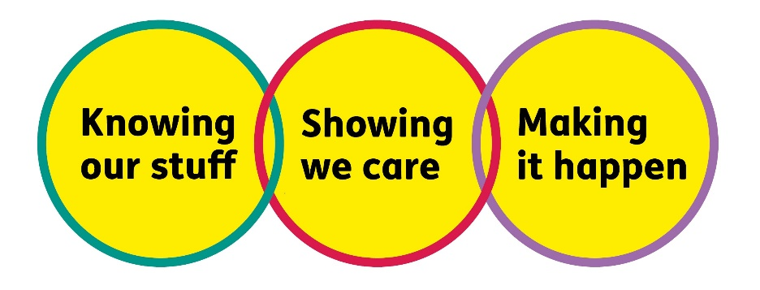
- Knowing Our Stuff - we have Integrity and we act Honestly

Showing We Care - we are Supportive and Caring

Making It Happen - we are Ambitious

About the role
- Contribute to community and events team income as set by community and events fundraising manager
- Work with fundraising colleagues to give excellent donor care to supporters
- Keep excellent records of all communications
- Assist the community and events fundraising manager to apportion income to supporter records
- Provide materials to supporters and to team colleagues who work from home
- Contribute to team meetings
- Identify opportunities for further income generation and donor recruitment, including through digital and social media
- Keep up to date with best practice and comply with relevant legislation
All our team members are expected to comply with Macular Society terms and conditions, rules, policies, procedures, codes of conduct, quality standards, authorisation processes, risk management policies and relevant external regulations.

About you
1. You will be committed to equality, diversity and inclusion in all aspects of our work.
2. You will have an open and collaborative approach to work, helping us to achieve our Knowing Our Stuff value by working with integrity, making informed decisions to be the best we can be to Beat Macular Disease.
3. You will be able to act with empathy, providing a caring, approachable and supportive environment for all – we Show We Care by listening to each other and working together.
4. You will be ambitious in your approach to help Make Things Happen, we are progressive yet supportive, and brave in our actions to make the progress that is needed to Beat Macular Disease.
5. You will be happy to work in an organisation that puts those we support first, advocate for the Macular Society at all times, and be comfortable that all members of the team are part of our fundraising culture.

Specifically for this role:
You will have experience of working in a fundraising or similar environment and have an understanding of what excellent donor stewardship looks like.
Knowing Our Stuff
- Excellent organisational and influencing skills and a can-do, hands-on approach
- Willingness to grow knowledge about macular conditions and latest research news
- Great attention to detail and accurate reporting skills
- Strong written and verbal communication skills

Making It Happen
- Up-to-date digital marketing skills and ability to manage diverse and demanding workloads
- Able to work independently under own initiative and cooperatively as part of a hybrid-working team
- Strong IT skills including Word, Excel, PowerPoint, Outlook

Showing We Care
- Demonstrable experience of delivering excellent supporter/customer care
- Excellent team working and collaborative working skills and the ability to develop effective partnerships
- Commitment to high standards in all areas of work

Eligibility to work in the UK:
Proof of identity and eligibility to work in the UK.

Volunteering:
From time to time you may be asked to support / volunteer your time (TOIL available) at Macular Society events that take place outside of normal working hours.

Safeguarding:
The Macular Society is committed to safeguarding and promoting the welfare of all children, young people and vulnerable adults with whom we work. We expect all of our employees and volunteers to demonstrate this commitment.
You are required to carry out other such duties as may reasonably be required, relevant to the role.
This job description is accurate as at the date shown below. In consultation with you it is liable to variation by the Macular Society to reflect or anticipate changes in or to the role.

Annual leave: 26 days plus bank holidays (pro rata for part time)
Based: Andover with some home working
Contract Type: Part Time, 22.5 hours per week, days to be discussed

Date of evaluation: 5 August 2025

