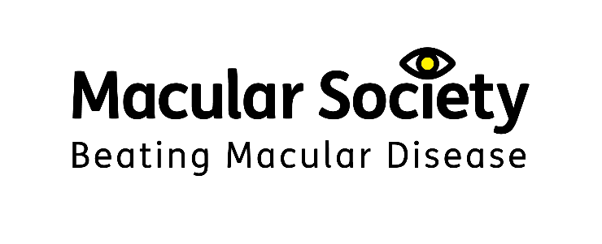

# Macular Society

# Minutes of the Annual General Meeting 2023

This meeting took place by video conference.

**Date:** Saturday 16 September 2023

**Present:** Cecilia Bufton, Chair and Company Director

Richard Piller, Honorary Treasurer and Company Director

Cathy Yelf, Chief Executive and Company Secretary

100 members were also present online.

The meeting began at 16.00.

The Chair, Cecilia Bufton welcomed those present to the 2023 AGM.

## Item 1: Minutes of the AGM meeting 2022

1. The Minutes of the meeting of Saturday 10 September 2022 were approved.

**Proposed Pauline Carrier. Seconded Qihui Zhang.**

**Votes for 35 (including 1 proxy vote), against 0, abstentions 3.**

Whilst waiting for the votes, the Chair thanked Powys Association of Voluntary Organisations (PAVO), who have given us a grant of £7,500 over three years, from the Welsh Government’s Connected Communities: Loneliness and Isolation Fund for volunteer-led services, for emotional support for people with sight loss in Powys.

## Item 2: Report and Accounts for 2022

1. The Honorary Treasurer, Richard Piller, presented the Annual Report and Accounts for the year ending 31 December 2022. The report and accounts were approved.

**Proposed Roger Stephenson. Seconded Roger Pepper.**

**Votes for 25 (including 1 proxy vote), against 1, abstentions 0.**

## Item 3: Appointment or reappointment of members of Council and Officers

1. The Chair informed the AGM that the following Trustees were

reappointed: Richard Piller for a third three-year term as Honorary Treasurer starting June 2023, and Cecilia Bufton for a second three-year term as Chair starting September 2023.

The following Trustees retired in September 2023: Anna Fletcher, Frances Luff and Stephen Stacey having completed their second term. Elaine Latham and Patrick McGeough will not be taking up their second term. CB recorded her thanks on behalf of the Society for everything they have done to help steer the Society to such a strong position.

## Item 4: Appointment of Auditors and authorise Directors to fix their remuneration

1. The Honorary Treasurer informed the AGM that Clifford Fry have acted as our external auditors for a number of years and provide an excellent service. He recommended that we reappoint Clifford Fry for a further year and allow the Directors to fix their remuneration for the coming audit. The Chair asked the AGM for someone to propose and second that proposition. The Honorary Treasurer confirmed as a point of good governance that the Society will be putting our audit out to tender next year after the next audit round has been completed.

**Proposed Bea Nicholson. Seconded Pauline Carrier.**

**Votes for 10 (including 1 proxy), against 1, abstentions 0.**

**The Auditors were duly appointed for another year.**

## Item 5: Any other business

1. The Chair recommended some changes to our Articles of Association, firstly that we changed the term from ‘Council of Trustees’ to ‘Board of Trustees’. This is in line with usual charity practice.

**Proposed Jack Davies. Seconded Marion Reed.**

**Votes for 4 (including 1 proxy), against 0, abstentions 1.**

Secondly, that the Articles include a provision for the Board and its Committees to hold meetings virtually (online) when required. This was permitted by the Charity Commission during the pandemic but if it is to be a permanent option, the Commission recommends that the Articles reflect that policy. Consequently, we intend to amend the Articles to the effect that meetings can be held virtually.

**Proposed Judy Plys. Seconded Rebecca Mullins.**

**Votes for 4 (including 1 proxy), against 0, abstentions 0.**

The Chair thanked the researchers, clinicians, scientists, members, volunteers, donors, supporters, staff and trustees and all of those who support the work that the Society does.

There being no other business, the meeting closed at 16.30.